Ravenshall School
Looking After Yourself: Self-Care
Parent/Carer Session
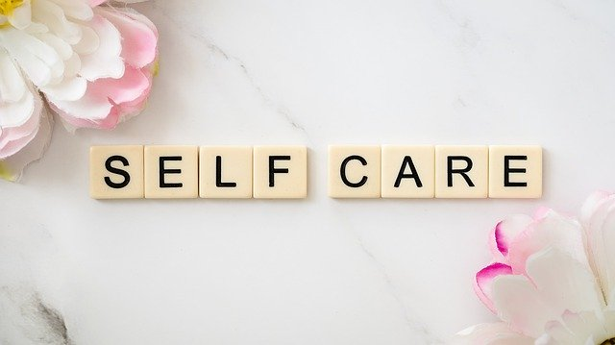
Date: Friday 8th December 2023
Time: 9:30 a.m.

Come and join me for an informal parent/carer information session, where we will discuss the benefits and challenges of self-care, along with strategies and resources to help put this in place. You’ll get a little pamper bag to take home too.
Please let Liz Blythe know if you would like to attend this session as I need to know how many bags to make up.
Tel: 01924 456811
Email: liz.blythe@ravenshall.org

I look forward to seeing you all.
Dee MacLeod
KKIM Parent & Community Worker

