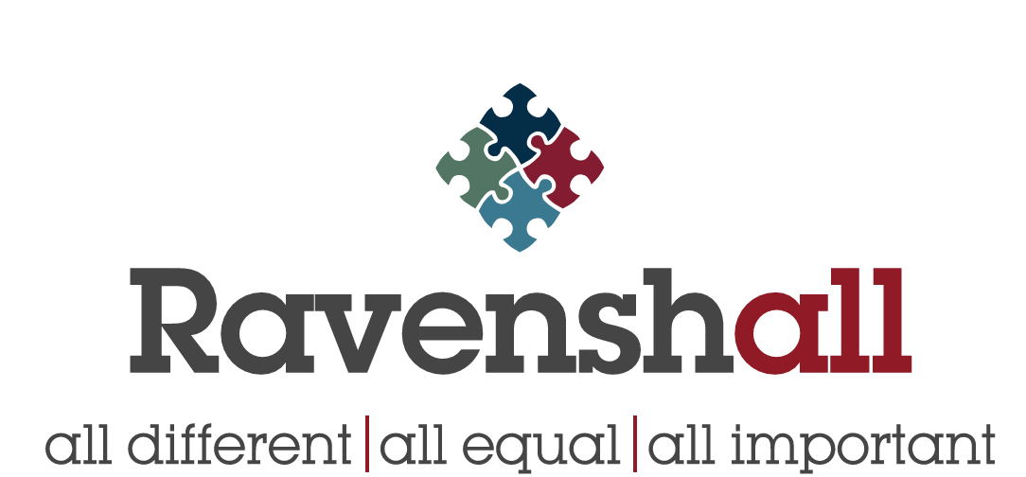

Privacy Notice
How we use pupil/parents’ information

Who processes your information?

Ravenshall School is the data controller of the personal information you provide to us. This means the school determines the purposes for which, and the manner in which, any personal data relating to pupils and their families is to be processed.

In some cases, we may share your data will be outsourced to a third-party processor; however, this will only be done with your consent, unless the law requires the school to share your data. Where the school outsources data to a third-party processor, the same data protection standards that the school upholds are imposed on the processor.

Danielle Eadie, from RADCaT Ltd is the data protection officer, and who the school has nominated to support and advise on technical data protection matters. He will be supported for all matters data protection by the school’s leadership team. Their role is to oversee and monitor the school’s data protection procedures, and to ensure they are compliant with the GDPR. The data protection officer can be contacted on 01924 456811 or office@ravenshall.org

The categories of pupil information that we collect, hold and share include:
- Personal information (such as name, unique pupil number and address)
- Characteristics (such as ethnicity, language, nationality, country of birth and free school meal eligibility)
- Attendance information (such as sessions attended, number of absences and absence reasons)
- Special categories of information (such as assessment information, exclusions and behavioural information)
- Special Educational Needs Information

Whilst the majority of the personal data you provide to the school is mandatory, some is provided on a voluntary basis. When collecting data, the school will inform you whether you are required to provide this data or if your consent is needed.

Where consent is required, the School will provide you with specific and explicit information with regards to the reasons the data is being collected and how the data will be used.

Why we collect and use this information:

Ravenshall School holds the legal right to collect and use personal data relating to pupils and their families, and we may also receive information regarding them from their previous school, LA and/or the DfE.

Also, when a pupil transitions from primary school to secondary school, we have a legal obligation to transfer certain personal data, including the pupil’s educational record and certain special categories of personal data (such as ethnic origin), to the secondary school that the pupil will attend. This transfer takes place no later than 15 school days after the pupil ceases to be registered at the primary school and is carried out using secure file transfer services including the Department for Education’s school-to-school (S2S) system, and the Child Protection Online Monitoring and Safeguarding system (CPOMS).

However, it is often necessary or beneficial for secondary schools to receive this information earlier, usually in March, so that they can make the necessary preparations for the arrival of new pupils. In respect of any information which the secondary school requires, at this early stage, in order to fulfil its duties as a school and a public authority (including any information necessary to make any preparations for safeguarding purposes or to make reasonable adjustments for disabilities), our legal basis for transferring this information is that it is necessary for the performance of a public task.

Additional personal data about the pupil may also be transferred to the secondary school, at this early stage, which is not strictly necessary for the secondary school’s performance of its duties as a public authority, but which makes the process of transitioning from primary to secondary school more efficient and reduces the administrative burden both for the schools and, in some case, the parents or guardians of the pupil. In this respect, our legal basis for transferring this information is that it is necessary for the legitimate interest of both us and the secondary school in ensuring the smooth transition of pupils between the schools.

You have the right to object to this early transfer of information by contacting us and, if you do, we will only carry out this transfer where we can demonstrate that we have compelling, legitimate grounds to do so.

We collect and use personal data in order to process the data lawfully and as set out in the GDPR and UK law, including those in relation to the following:

For non-special/non-sensitive data:

- in relation to a contract for education with you and contained in the Education Act 1996.
- In relation to management of the school under the Education (Governor’s Annual Reports) (England) (Amendment) Regulations 2002 SI 2002, No 1171.
- In relation to School Admissions Code, Statutory guidance for admission authorities, governing bodies, local authorities, school’s adjudicators and admission appeals panels December 2014
- In relation to Regulation 5 of The Education (Information About Individual Pupils) (England) Regulations 2013
- (Departmental Censuses) are the Education Act 1996 – this information can be found in the census guide documents on the following website https://www.gov.uk/education/data-collection-and-censuses-for-schools

For special /sensitive data:

- In relation to the protection of children under the “Keeping children safe in education Statutory guidance for schools and colleges 2023”; “Working together to safeguard children. A guide to inter-agency working to safeguard and promote the welfare of children 2018.
- In relation to the safeguarding of children under the Safeguarding Act 2006 We use the pupil data:
- to support pupil learning
- to monitor and report on pupil progress
- to provide appropriate pastoral care
- to assess the quality of our services
- to advise of any curriculum related or community-based activities we undertake or encourage you to attend, this may involve sending a newsletter or brief via email.

Collecting pupil information

Whilst the majority of pupil information you provide to us is mandatory, some of it is provided to us on a voluntary basis. In order to comply with the General Data Protection Regulation, we will inform you whether you are required to provide certain pupil information to us or if you have a choice in this.

Storing pupil data

Personal data relating to pupils at the school and their families is stored in line with the School’s Retention Policy.
In accordance with the GDPR, the school does not store personal data indefinitely (However, there may be exceptions to this, where we have obligations under our insurance cover scheme to retain data for indefinite or protracted periods); all other data is only stored for as long as is necessary to complete the task for which it was originally collected.

Who we share pupil information with
We routinely share pupil information with:

- schools that the pupil’s attend after leaving us
- our local authority
- the Department for Education (DfE)
- other outside agencies (such as NHS, School Nurse, GMP, Careers)

What are your rights?

Parents and pupils have the following rights in relation to the processing of their personal data. You have the right to:

- Be informed about how school uses your personal data.
- Request access to the personal data that school holds.
- Request that your personal data is amended if it is inaccurate or incomplete.
- Request that your personal data is erased where there is no compelling reason for its continued processing.
- Request that the processing of your data is restricted.
- Object to your personal data being processed.
- Request my information in a machine-readable format i.e. Excel, word or a CSV file.
- Object to direct marketing and such objection not affect any dealings you have with us.

Where the processing of your data is based on your consent, you may be able to withdraw such consent in limited circumstances.

If you have a concern about the way the school and/or the DfE is collecting or using your personal data, you can raise a concern with the Information Commissioner’s Office (ICO). The ICO can be contacted on 0303 123 1113, Monday-Friday 9am-5pm or via this link https://ico.org.uk/concerns .

Why we share pupil information

We do not share information about our pupils with anyone without consent unless the law and our policies allow us to do so.
We share pupils’ data with the Department for Education (DfE) on a statutory basis. This data sharing underpins school funding and educational attainment policy and monitoring.
We are required to share information about our pupils with the (DfE) under regulation 5 of The Education (Information About Individual Pupils) (England) Regulations 2013.

Data collection requirements:
To find out more about the data collection requirements placed on us by the Department for Education (for example; via the school census) go to https://www.gov.uk/education/data- collection-and-censuses-for-schools.

National Pupil Database

The NPD is owned and managed by the Department for Education and contains information about pupils in schools in England. It provides invaluable evidence on educational performance to inform independent research, as well as studies commissioned by the Department. It is held in electronic format for statistical purposes. This information is securely collected from a range of sources including schools, local authorities and awarding bodies.

We are required by law, to provide information about our pupils to the DfE as part of statutory data collections such as the school census and early years’ census. Some of this information is then stored in the NPD. The law that allows this is the Education (Information About Individual Pupils) (England) Regulations 2013.
To find out more about the NPD, go to https://www.gov.uk/government/publications/national- pupil-database-user-guide-and-supporting-information.
The department may share information about our pupils from the NPD with third parties who promote the education or well-being of children in England by:
  - conducting research or analysis
  - producing statistics
  - providing information, advice or guidance

The Department has robust processes in place to ensure the confidentiality of our data is maintained and there are stringent controls in place regarding access and use of the data. Decisions on whether DfE releases data to third parties are subject to a strict approval process and based on a detailed assessment of:
  - who is requesting the data
  - the purpose for which it is required
  - the level and sensitivity of data requested: and
  - the arrangements in place to store and handle the data

To be granted access to pupil information, organisations must comply with strict terms and conditions covering the confidentiality and handling of the data, security arrangements and retention and use of the data.
For more information about the department’s data sharing process, please visit: https://www.gov.uk/data-protection-how-we-collect-and-share-research-data
For information about which organisations the department has provided pupil information, (and for which project), please visit the following website: https://www.gov.uk/government/publications/national-pupil-database-requests-received
To contact DfE: https://www.gov.uk/contact-dfe

Requesting access to your personal data
Under data protection legislation, parents and pupils have the right to request access to information about them that we hold. To make a request for your personal information, or be given access to your child’s educational record, contact Rachel Thackray Business Manager or Penny Oates Senior Business Support Officer.

If you would like to discuss anything in this privacy notice, please contact our Data Protection Officer, as follows:

Danielle Eadie
Data Protection Consultant
RADCaT Ltd
T: 01942 590785 | M: 07394 565 160
Email: danielle.eadie@radcat.co.uk

Or by post:

RADCaT Ltd, Suite 1.10, Unity House, Westwood Park, Wigan, Greater Manchester, WN3 4HE.

Contact
If you would like to discuss anything in this privacy notice, please contact: Rachel Thackray Business Manager on 01924 456811

