Alumni Case study
Pupil: Luke Shires
Overview
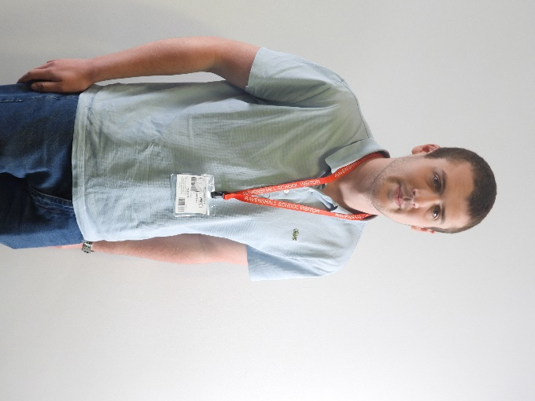
Luke Shires attended Ravenshall School from 2011-2020. As a pupil at Ravenshall we saw him mature into a polite and conscientious young man.
Luke attended all his lessons with enthusiasm and with a real determination to learn.
Luke left with GSCE Art and Entry Level 1 in Numeracy, Literature and Science.
Overall he was a quality student who left a lasting impression on both pupils and staff during his time at school.

Pupil background
Luke came to Ravenshall in Key Stage 1 and became a popular student with staff and peers alike. Luke thrived on positive praise for his achievements, as he worked extremely hard in every lesson and liked to be recognised for this.
Luke was very helpful and kind to staff and his peers. His attendance and punctuality were excellent.
In Key stage 4 Luke represented the school as a Senior Ambassador and he became a sports’ leader in Year 10.
Luke’s work experience was at a car mechanic’s garage in Thornhill. He loved his time there and was excited to be part of a working team. The reports from the garage expressed how happy they were with the placement.
Luke was a pleasure to have in Ravenshall School. In his time at Ravenshall he grew to be the epitome of a diligent and courteous young man.
Mrs. D Johnson KS4 Staff
SLT comment from his last report
What an absolute pleasure to have had this special young man at our school.
Luke has really grasped every opportunity presented to him and achieved much success both academically and socially. This is highlighted within his school report and celebrates his very many achievements through his hard work, determination, and caring personality.
I am delighted that you are now ‘College Ready’ and about to leave us for the next stage of your adulthood journey.
What a success you have made of your time here.
Luke has developed into a young adult who everyone likes and admires.
He has been the best role model for many of our vulnerable students, showing great empathy and encouragement in his many ‘leadership roles’.
I have been very impressed how Luke conducts himself in an outstanding Ambassador for example.
Luke has matured and improved his confidence over the last couple of years. This has been evident in the way his confidence and skill levels have increased to find sensible approaches to overcome some of the challenges he has faced.
Luke, you are a young man with a lot of potential to show in your next placement. I wish you the very best of luck as you enter the next phase of your journey into adulthood at college.
Well done and best wishes for the future!
Mrs.Tate
Parental comments-
Luke has grown into a mature young man, Thanks to the support he got at Ravenshall. He has a job and earns his own money. He can manage money basically and do many of the day to day things we take for granted like catching buses and organising himself. Ravenshall helped Luke become more confident and reinforced the positive things Luke does well and his overall character. We are grateful to Ravenshall for all their support. Luke also got a lot out of the work experience placement made and the Pathways he did in school. We strongly believe just because someone has issues with learning etc, they can do things and with support Luke does.

Current/Future destinations and ambitions-
In the future Luke would like to get full time job earning lots of money.

Supporting Luke in school
Luke has support in English, Maths and Work Skills through your EHCP

How do you feel Ravenshall helped you in terms of your mindset for the future and your achievements?

Ravenshall taught Luke he can do things and gave him confidence to try. They helped build his resilience and because teachers understood his needs he was able to achieve and was a very happy pupil at school.

What are your fondest memories of Ravenshall School?

There are many fond memories of school Luke fondest memory of Ravenshall was party in the park and performing in the Christmas show.

